Everyday Women of Sitka: Lakrisha Johnson

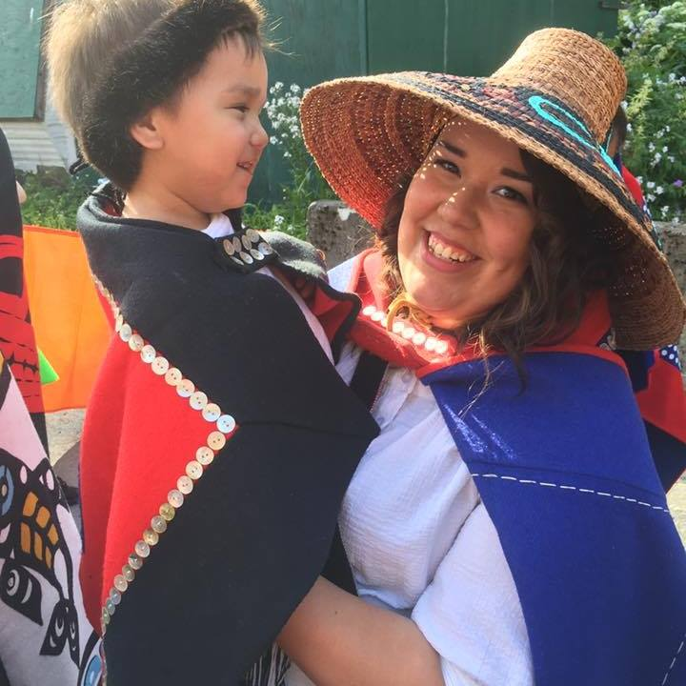

- Can you please tell me a little about yourself? How long have you lived in Sitka? What types of things are you involved in here?
Chookán yóo xat duwasáakw, Dleit kaa x’éináx Lakrisha. Ch’áak’ naax xat sitee. Chookaneidí áyá xat, Kiks.ádi yádi xat sitee.
My name is Chookán, in English they call me Lakrisha. I am adopted into the eagle moiety, in the Chookaneidí clan. My father’s people are the Kiks.ádi.
I was born in 1991 and raised here in Sheet’ká (Sitka). I grew up in the Sitka Native Education Program (SNEP) and participated in programs from preschool through 12th grade. I began my teaching career as a student instructor with SNEP in 2008. I have been fortunate enough to grow into a Co-Director position with SNEP, thanks to the love and support of many. I’m very passionate about this work for a variety of reasons. My grandma, Yeidikook’áa, Isabella Brady, began this program with the irreplaceable help of Kaal.átk’, Charlie Joseph, Sr., back in 1974. For a long time, her entire life was dedicated to this work, and I try to remember that every day, and attempt to bring my whole self into this work as well.
In addition to this work, I love dancing and singing with multiple Lingít dance groups. In these groups, I am often surrounded by friends and families who hold similar cultural values as I do.
- What is your biggest struggle right now?
A big part of my job is usually face-to-face time with students. Currently, there are a lot of mandates and rules in place that limits us to exclusively virtual “face-to-face” time. This can make it difficult for those more organic teaching opportunities to arise, or for spontaneous moments to just hang out and be together. I’m realizing how beneficial these moments were to my overall well-being. I struggle a lot with this, mostly because I fear that if this has been challenging to my mental health, what kind of effect has it had on our students? I enjoy being someone who is available and approachable for students, and that is something that’s difficult to maintain when there are no opportunities for face-to-face conversations.
- What does a normal “Day in the Life” look like for you? What changes happened in this time of the pandemic?
Pre-COVID, I would spend my days developing and delivering cultural curriculum. I spend time with amazing community partners who also value this work, and I gain a lot from this time. Nowadays, it is essentially the same, but almost entirely virtual. Just like most folks, I am navigating this virtual world with a new lens. This can be daunting at times, but it also opens up a lot of doors. We can now focus on digitizing amazing stories, art lessons, language lessons, and song and dance lessons for our students. Eventually, even post-COVID, this virtual library has the possibility to add so much depth to our program.
- What makes you proud to be a woman?
I love this question, because it is honestly the first time I’ve ever been asked this. In thinking about how to answer this, I realized the moments when I felt most proud to be a woman, were all focused on other women in our community. I grew up watching incredibly strong drummers, dancers, singers and language speakers, and I remember thinking to myself, “if I could be half the woman that drummer is, I will feel proud”. The moments I’ve been on stage and felt a twinge of pride, it is because I thought of those women before me, and how they were able to portray a love for this culture just by the way they present themselves on stage. So for me, I am proudest when I can see attributes of these mentors, leaders, elders, and teachers in myself.
- Do you have something you’d like to say to other women in Sitka?
I’d like to encourage other women in Sitka to find something that makes them happy. What are you passionate about? What can shift your entire mood into a more positive space?
For me, identifying these was the first step into finding my “non-negotiables”. This can be applied to both my professional and personal life. Set boundaries, and intentionally make space for these things that make you happy. Honor yourselves the way so many of you honor those you love.

