Everyday Women of Sitka: Devin Tatro

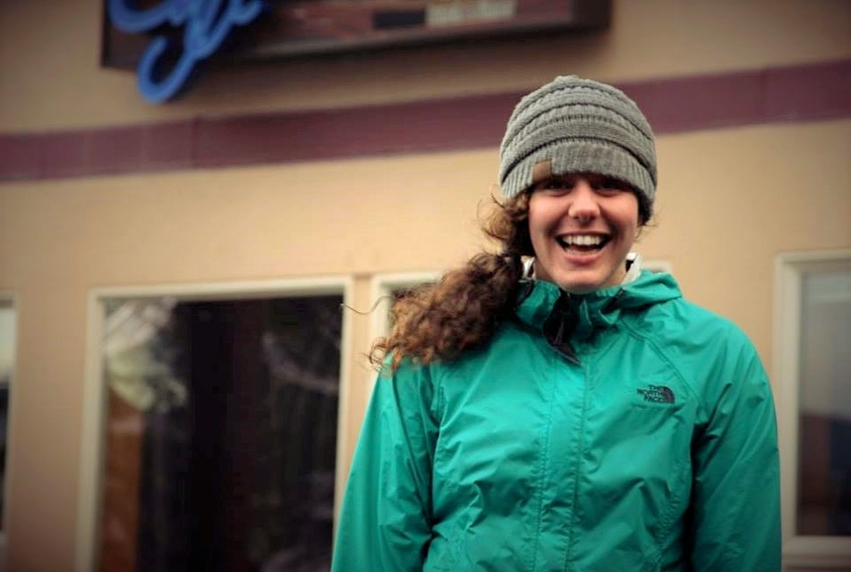

- Can you please tell me a little about yourself? How long have you lived in Sitka? What types of things are you involved in here?

My name is Devin Tatro. I have lived in Sitka for three years. I am a student teacher at Blatchley Middle School and I am getting my Master’s in teaching right now. I teach 8th grade social studies. And I absolutely love that part of my life right now. Let’s see, I am really enjoying being at Blatchley. I am a long distance runner. I play music. In the community here, I am on the Search and Rescue Team and the technical Mountain Rescue team. Let’s see what else about myself. I spent my time in Sitka before this as an AmeriCorps and working for Youth Advocates of Sitka.

- What is your biggest struggle right now?

Let me think for a minute because there are lots. My biggest struggle right now is reconciling the feeling like the need or urge to prove myself as someone who is young and setting a career and entering new fields. I often feel the need like I have to prove that I can do it, but that can cause pressure and that can perpetuate energy focused on the wrong things. I am learning to think less about how successful I am appearing to be and think more about turning the energy into actions that I know are important like listening to people and being positive and contributing to fill in needs that are around me and to be open instead of getting narrowed in or checking off boxes to what I think constitutes success.

- What makes you proud to be a woman?

What makes me proud to be a woman is the qualities that in our society that are traditionally seen as feminine like primarily nurturing and patience and empathy, I think are so powerful and entirely necessary for our world to be strong and yeah that makes me be proud to fully strive to embody those qualities.

- Who was/ is a female role model for you? Why?

Let’s see well I have a lot of female role models where I work at Blatchley Middle School. The first is my mentor teacher, Roxann Gagner. The second I’ll mention is one of our administrative assistants, Allison Hackett. And the third is our librarian, Kari Sagel. I can talk a little about each one. Roxann, she is the mentor teacher for my MAT program so I have been working with her all year. And when we got kind of paired up together, I think people were almost maniacal about it. They were kind of laughing like you and Roxann are so different, it’s gonna be interesting. And Roxann and I are really different, but one of the things I admire about her the most is that she really has the capacity to care about anyone and be very responsive and able to adapt herself and the way she communicates to work with all different types of people and she really dedicates her whole life and all of her time to caring about other people: her students, her family, her kids; and it seems like all of the time is spent on really stepping up for others. The biggest thing is that she always stands up for other people, but also stands up for what she believes in. She never lets anything float by without putting a hand on it or stepping in if she needs to. The second person, Allison Hackett works in the office at our school, and she is very exceptionally assertive and warm in a way that I would like to imitate. Like she is able to diffuse tense situations very graciously. She has had kids come up to her very anxious and crying and staff members at the same level, and she is always able to very gently, kindly get them what they need. She always makes my days better. The third person is also someone who always makes my days at Blatchley better and serves as a mentor to me, and that is Kari Sagel. She is exceptional because she does so many things above and beyond to help students and help the school to be a brighter place and she doesn’t seek any recognition for it. She really digs into the small and nitty gritty things that no one else wants to put their hands on. And at the same time, she is very well spoken and critical in a very cautious and positive way.

- Why do you think you were nominated to be featured on our Facebook?

Well, I am hoping it is kind of a Murphy’s Law type thing. Every woman of Sitka deserves to be recognized and it just happens to be my turn. That is why this little program is so incredible and needed that we have. There are so many shockingly amazing women that we need to build up and I think this is a great example of how to build up women in a small way.

- What does a normal “day in the life” look like for you?

So right now, I spend my days at Blatchley mostly in an 8th grade social studies classroom teaching and observing and learning how to be a teacher. I also teach a home ec class with Roxann Gagner. Let’s see, so every day is totally a blast and the days that aren’t as fun are meaningful. After school right now, I am coaching the boys and girls track and field team at Blatchley which has been very dynamic and fun to interact with the kids in a different way. After that when I am home, I am finishing up my master’s degree. I take classes online through UAS. I usually run every day because that is what keeps me grounded. And when I have spare time, I play music and I play once a week at the Pioneer Home. I play old time music for residents. I have to fit in that kind of thing, and also try to attend community events when I can.

- Do you have something you’d like to say to other women in Sitka?

Well, I’ll say a narrative I constantly want to give to my middle schoolers, and I think it applies to everyone. It goes like this: ok female student in the second row who kind of half raised your hand and whispered an idea before you got cut off by the class clown in the back of the room who distracted everyone, you had the right idea, let’s go back to you, and let’s let your voice be heard. And to everyone else, when you see a girl with her hand half raised, kind of whispering an idea and people are cutting her off, help her get a chance to speak. Tell other people to be quiet and listen. I think that is analogy in my classroom that really shows what is going on all around us from the top down. Women and girls are constantly being told to step up, but there isn’t additionally narrative around that about cultivating an environment in which women and girls can successfully step up. And I want to tell women to hang in there and cheer each other on and constantly be looking for opportunities and ways in which they can amplify each other’s voices so that this process can keep going and we can really get the voice that we need because I have seen lots of young female students with the right answer and right idea get shut down and cast to the side. And that is kind of an analogy but it also what really happens, and then nobody gets the right answer.

- What does being a strong woman mean to you?

I think that in our society, there are so many things that women especially go through and endure with grace and pose that they shouldn’t have to go through alone or at all. And to be a strong woman to me, is to be someone to turn to when those things happen. I want to be someone to turn to when those things happen. I also think that strong women cheer for other women and don’t put down anyone. And then strong women balance taking care of their own needs with stepping up and showing up for other people.

