Everyday Women of Sitka: Karin Mullins
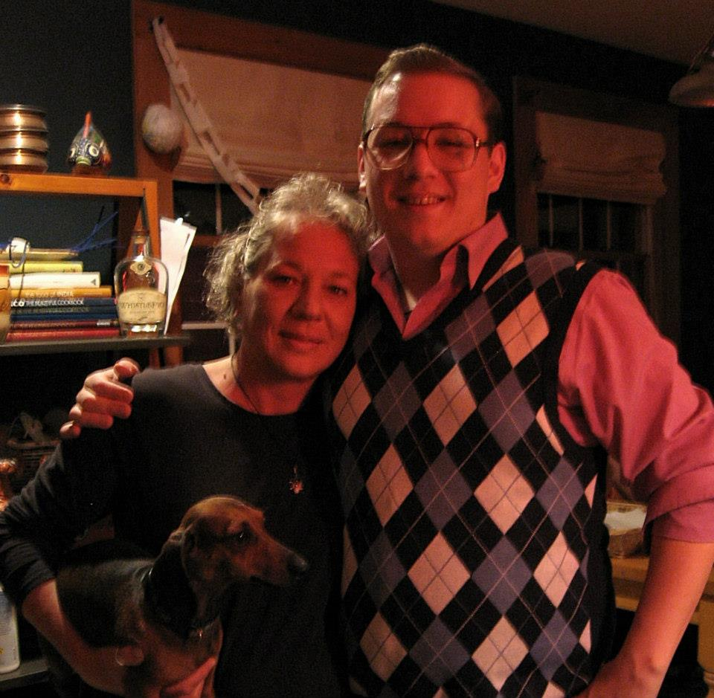

- Can you please tell me a little about yourself? How long have you lived in Sitka? What types of things are you involved in here?

I am a wife. I am a mother. I am a child advocate all the time, every minute. I am German and Swedish, but I am a lot German. I am an animal lover. I am an environmentalist. I care about the earth and our resources and I am worried about the earth and the whole state of what is happening. I moved to Sitka in June of 1994. That is almost 24 years. I haven’t been involved in a whole lot except for SAFV. That is the biggest thing I have done here. I don’t go out and do a lot of things. Whatever SAFV is doing, that is what I am involved in. I started to volunteer at SAFV in August of 1994 and I have been here in some capacity ever since.
- What is your biggest struggle right now?

My mother is getting old and sick and it is a really hard thing to watch and accept. I can’t help her and I can’t fix anything, and that is the hardest thing for me. My daughter is with her and that is very helpful and I am going down soon, but it is hard.
- What does a normal “day in the life” look like for you?

I have no normal life. I wake up and I don’t know what is coming today or tomorrow. I like that. That is why I like my job at SAFV. I never know what I am going to do. My life is very sporadic. I could leave on an airplane. I am working today which I don’t do every day. I don’t have a schedule or a plan. I just go with the flow. I have always been like that. I am a Gemini which is part of that I do believe. I don’t like a plan either. If I make a trip, I just want to have a good time. I am really good with no plan.
- What makes you proud to be a woman?

My strength, my heart, my feelings. I don’t think men have part of that. I really do believe they think differently and that they don’t think with their heart. I do.
- Do you have something you’d like to say to other women in Sitka?

I would like to say: Don’t sell yourself short ever and don’t think you are not enough. Don’t wait to do things that you really think you need to do. Love yourself because you are the one who will love yourself the most, and you can take care of yourself the most.

